**Practical – 7**

**Aim:- Inter-VLAN Routing**

**Topology:-**

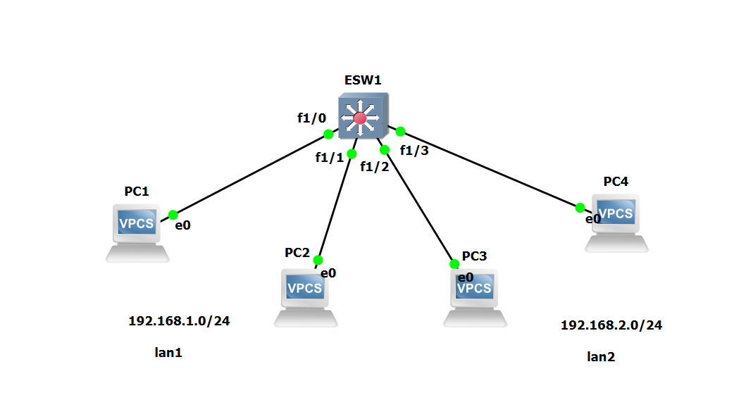

**PC1 Console**

ip 192.168.1.1/24

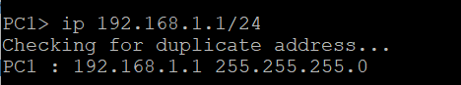

**PC2 Console**

ip 192.168.1.2/24

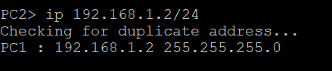

**PC3 Console**

ip 192.168.2.1/24

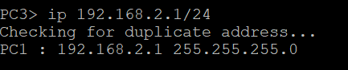

**PC4 Console**

ip 192.168.2.2/24

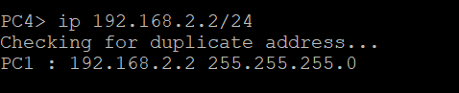

**ESW1 Console**

vlan database

vlan 10

vlan 20

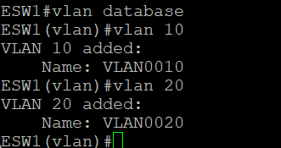

**ESW1 Console**

show vlan-switch

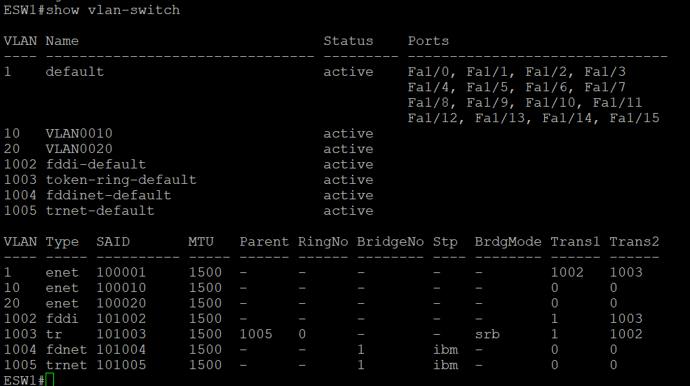

**ESW1 Console**

conf t

interface f1/0

switchport mode access

switch access vlan 10

exit

interface f1/1

switchport mode access

switch access vlan 10

exit

interface f1/2

switchport mode access

switch access vlan 20

exit

interface f1/3

switchport mode access

switch access vlan 20

exit

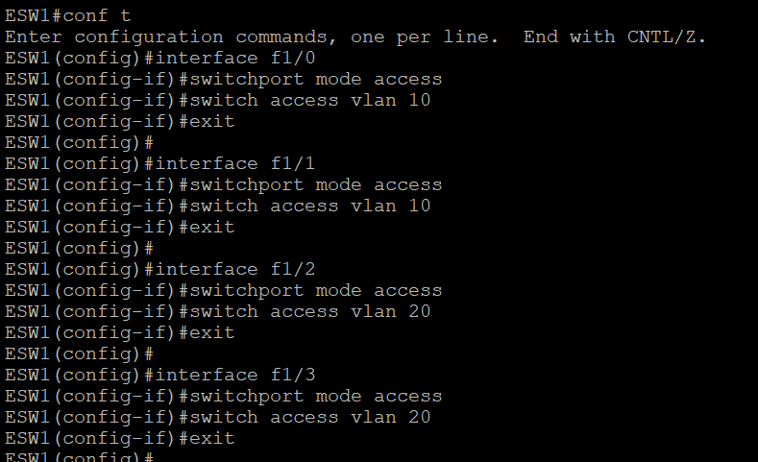

**ESW1 Console**

show vlan-switch

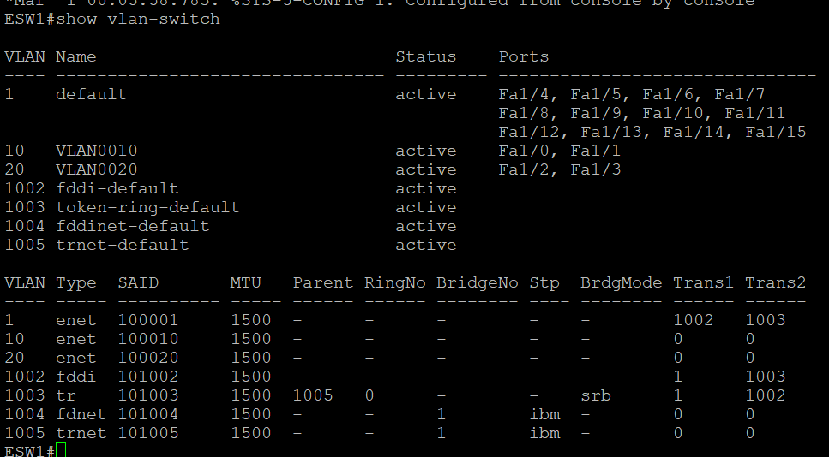

**PC1 Console**

ping 192.168.1.2

ping 192.168.2.1

show ip

ip 192.168.1.1/24 192.168.1.254

show ip

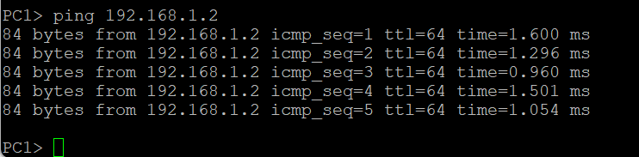



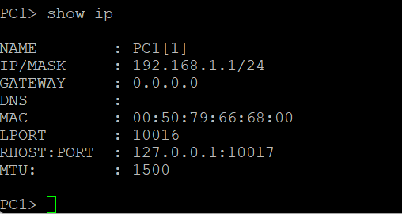

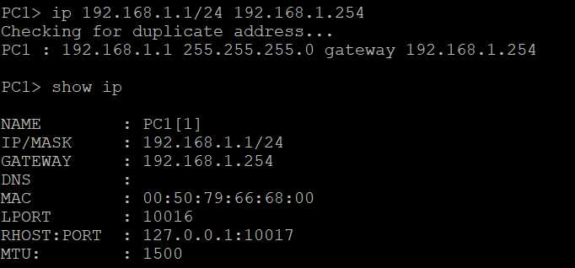

PC2 Console

ip 192.168.1.2/24 192.168.1.254

show ip

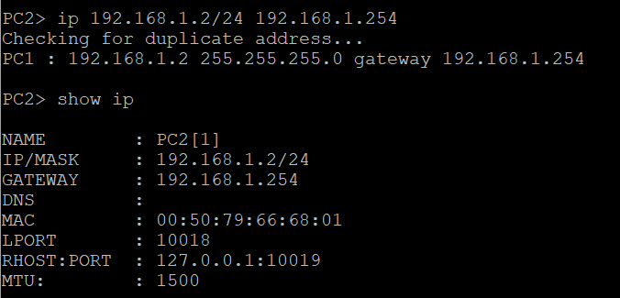

**PC3 Console**

ip 192.168.2.1/24 192.168.2.254

show ip

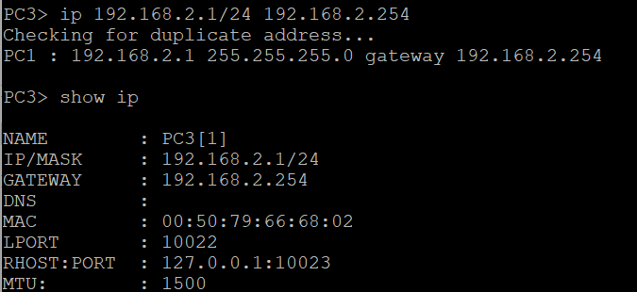

**PC4 Console**

ip 192.168.2.2/24 192.168.2.254

show ip

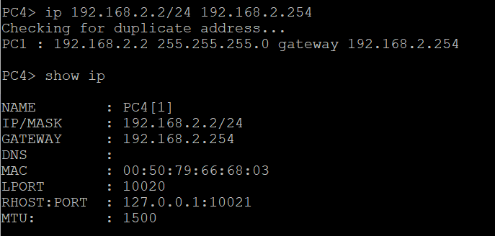

**EWS1 Console**

conf t

interface vlan 10

ip address 192.168.1.254 255.255.255.0

no shutdown

exit

interface vlan 20

ip address 192.168.2.254 255.255.255.0

no shutdown

exit

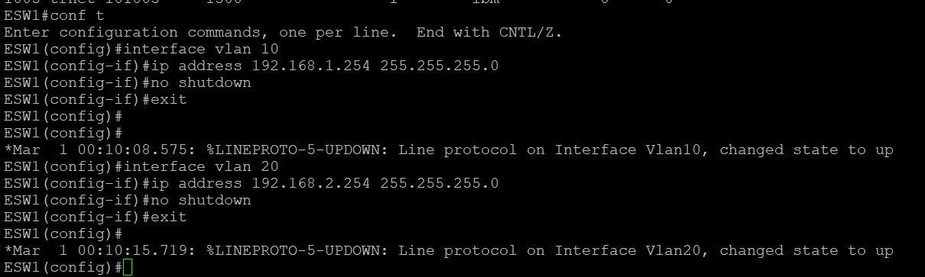

show ip route

conf t

ip routing

end

show ip route

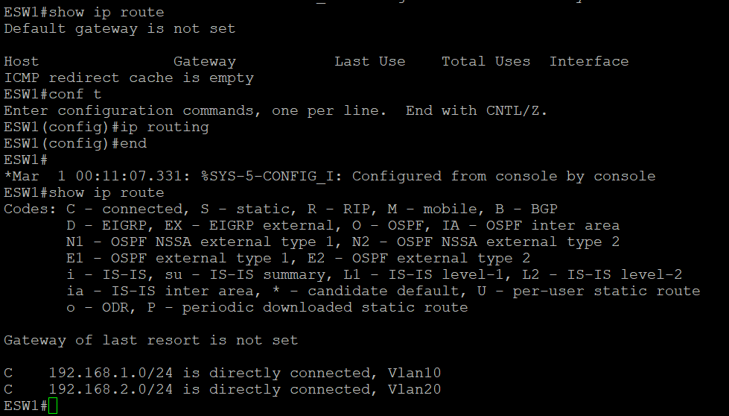

**PC1 Console**

ping 192.168.2.1

ping 192.168.2.2

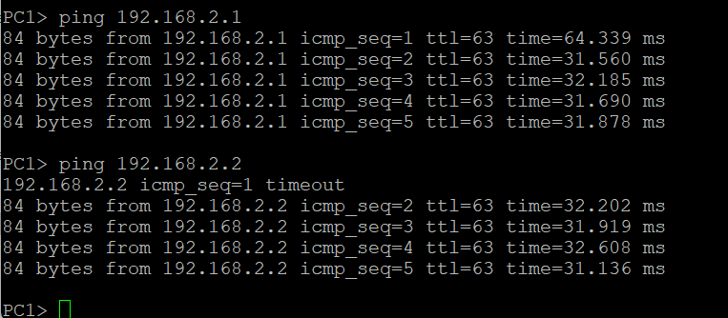

**PC4 Console**

ping 192.168.1.1

ping 192.168.1.2

